**ASSIGNMENT OOPS 9**

**/*Implement a map associative container in which the keys will be the Permanent Registration Number (PRN) of the students and the values will be the name of the respective student. Develop a program that prompts the user for PRN and then it looks in the map, using the PRN as an index and returns the name of the student.*/**

**PROGRAM:**

**#include <iostream>**

**#include <map>**

**using namespace std;**

**int main() {**

**map<int, string> populationMap;**

**populationMap[1234] = "Amit XYZ";**

**populationMap[2222] = "Rahul";**

**populationMap[3333] = "Shweta";**

**populationMap[4444] = "Aditi";**

**populationMap[9999] = "Pooja";**

**populationMap[7777] = "Ketaki";**

**cout << "======== Student List ==========\n";**

**cout << "Size of map: " << populationMap.size() << "\n";**

**for (auto iter = populationMap.begin(); iter != populationMap.end(); ++iter)**

**cout << iter->first << " : " << iter->second << "\n";**

**int PRN;**

**cout << "\nEnter PRN of student: ";**

**cin >> PRN;**

**auto iter = populationMap.find(PRN);**

**if (iter != populationMap.end())**

**cout << PRN << "'s name is " << iter->second << "\n";**

**else**

**cout << "PRN not found!\n";**

**return 0;**

**}**

**OUTPUT:**

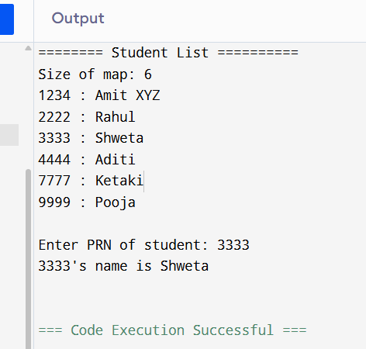

**GITHUB:**